**Coding Problem (11/11/2024)**

1. **Floor in Sorted Array:**

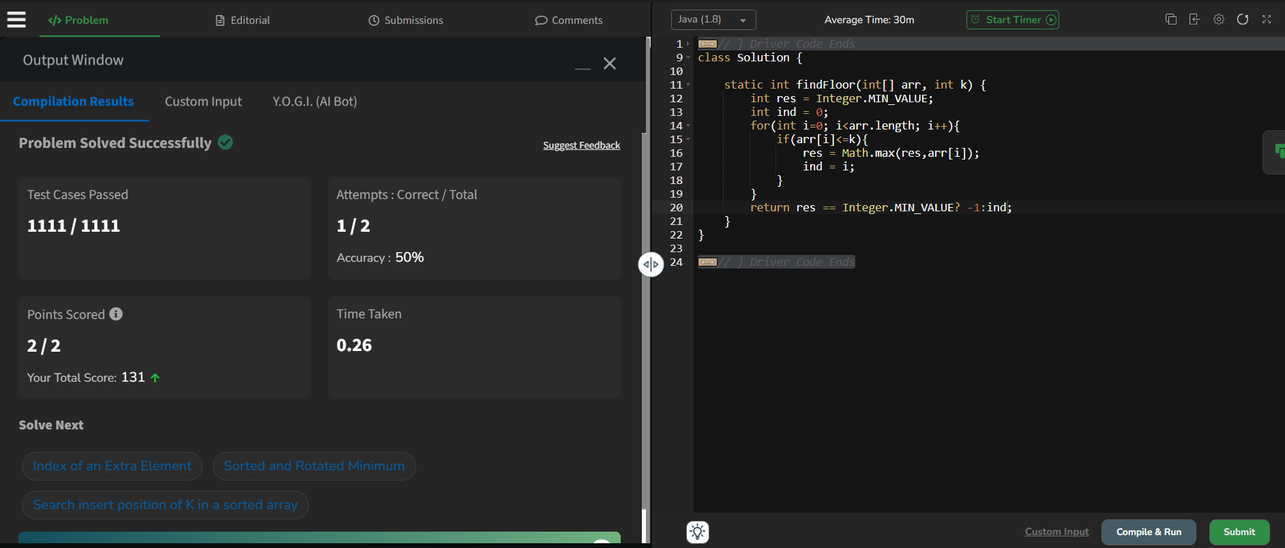

**Time Complexity : O(N)**

**Space Complexity : O(1)**

1. **Check Equal Array**

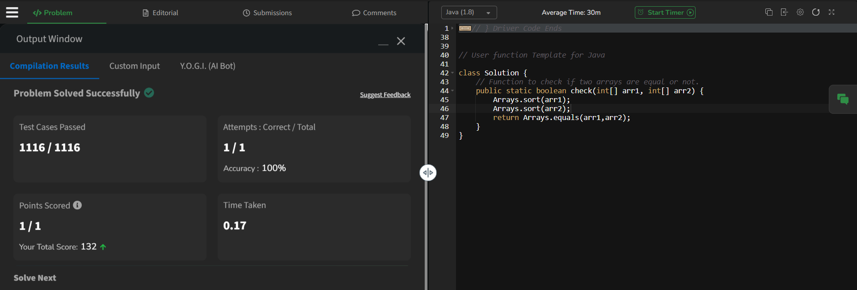

**Time Complexity : O(NlogN)**

**Space Complexity : O(1)**

1. **Palindrome Linked List:**

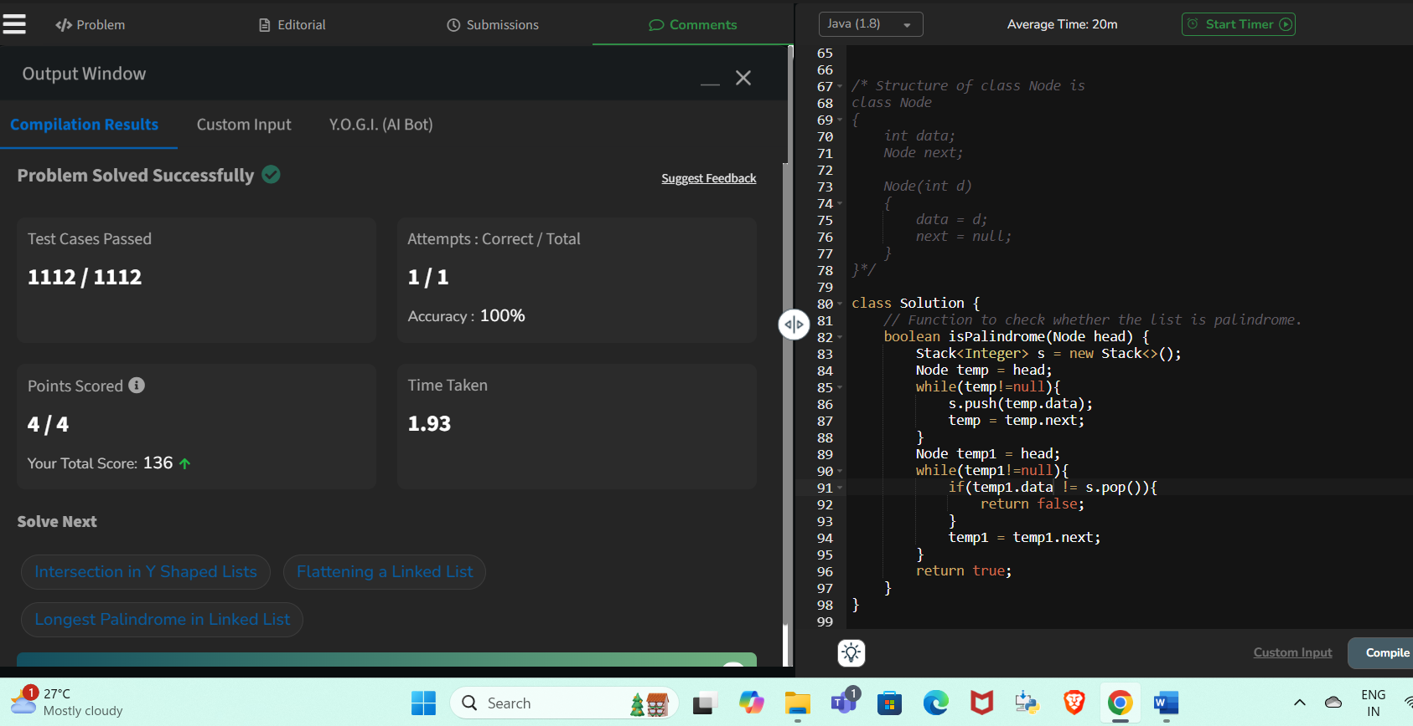

**Time Complexity : O(logN)**

**Space Complexity : O(N)**

1. **Triplets sum in Array:**

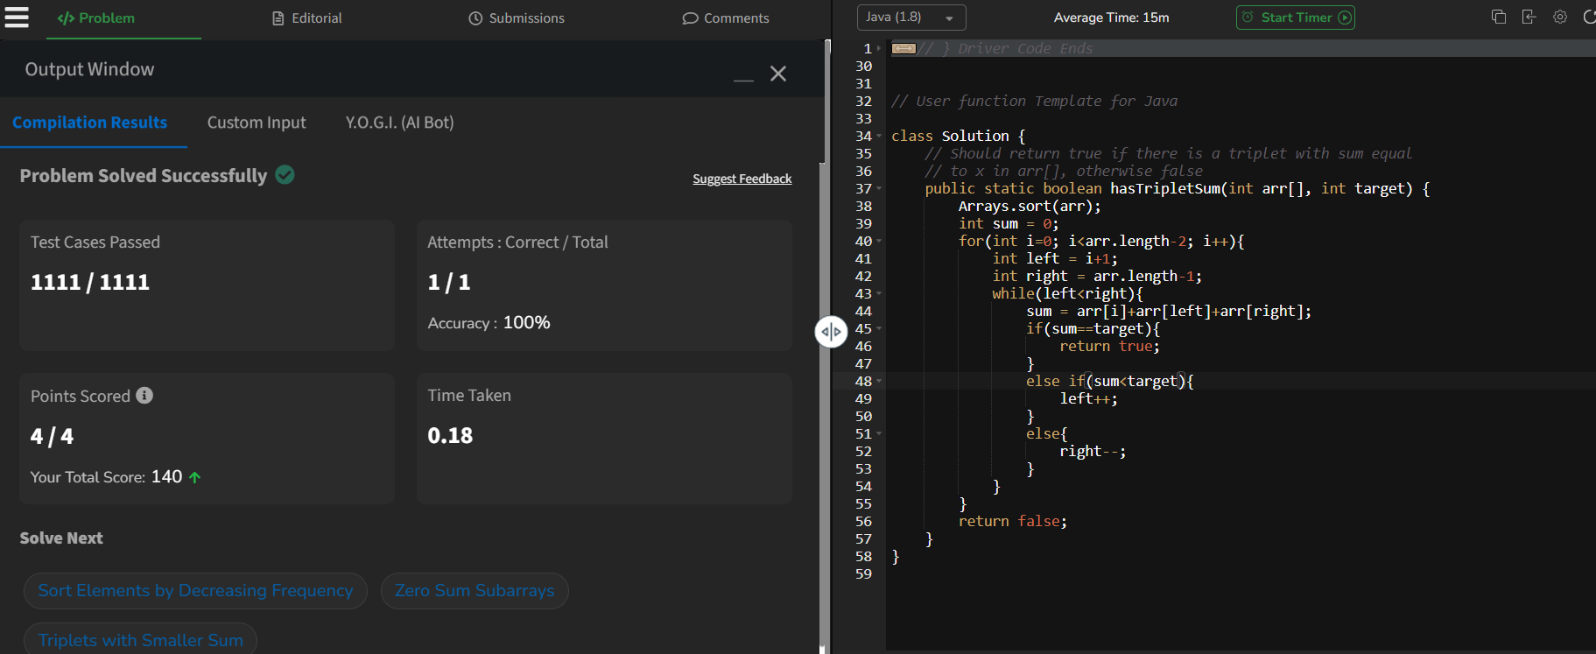

**Time Complexity: O(NlogN)**

**Space Complexity : O(1)**

1. **Balanced Tree Check:**

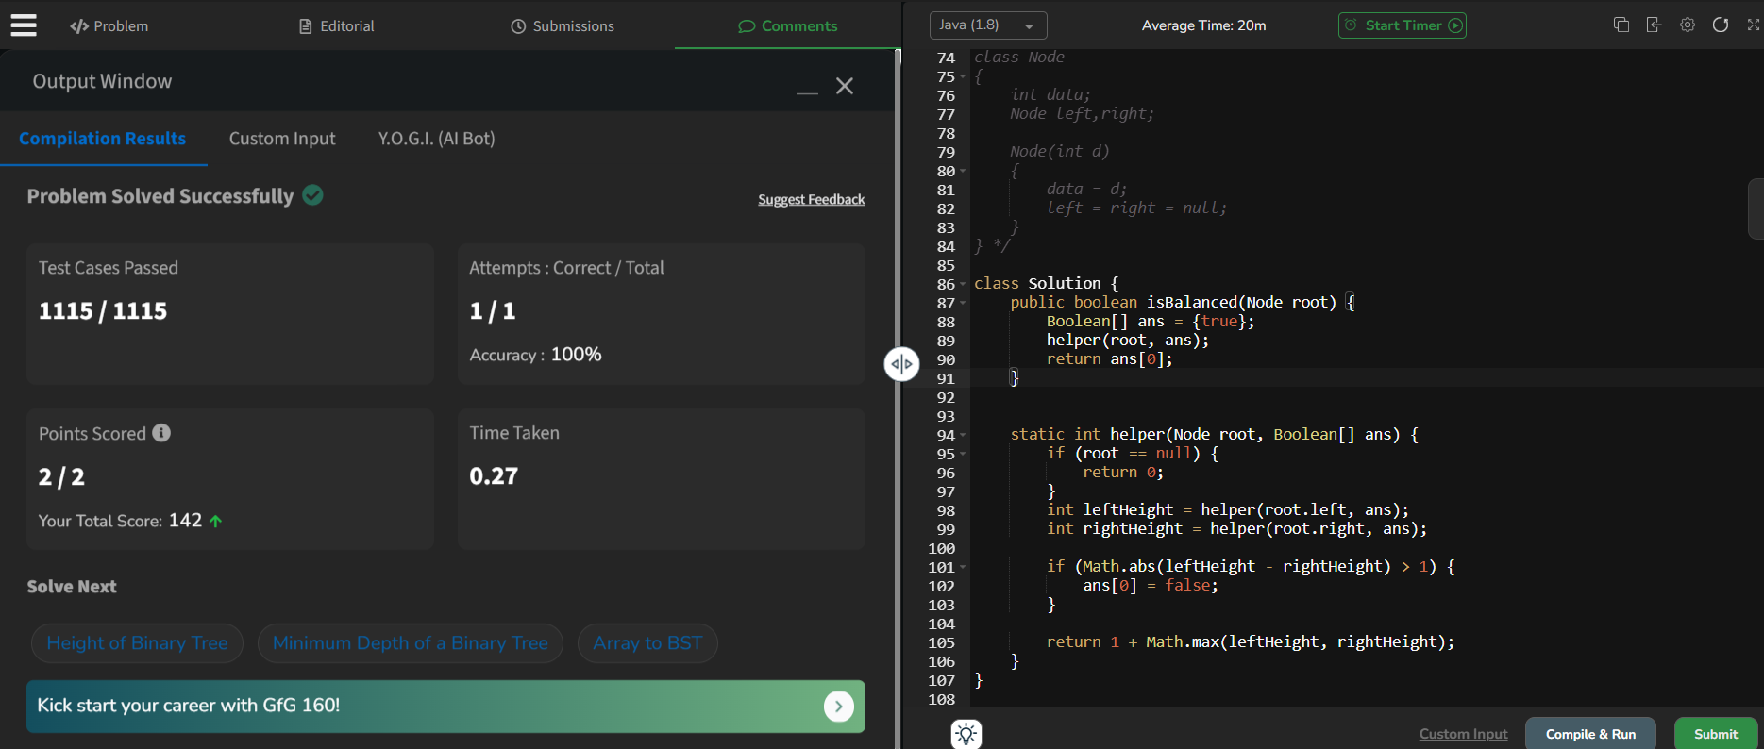

**Time Complexity : O(n^n)**